
Capstone Project Phase B
61999
Authorship Verification Using
Impostor Projections and Siamese Networks
Team Code: 26-1-R-27
Student: Ameer Masoud
Supervisor: Prof. Zeev Volkovich
GIT Repository: https://github.com/amirm10/FinalProject/tree/main
(Phase A and Phase B journals, full source code, poster, and video)
Braude College of Engineering
Department of Software Engineering

Table of Contents
Table of Contents 2
1. Background and Problem Summary 5
2. Project Description 6
2.1 General Description 6
2.2 Solution Description — Algorithms and Method 7
2.2.1 Siamese BERT Encoding 7
2.2.2 CNN–BiLSTM Refinement 8
2.2.3 Distance Metric and Training Objective 8
2.2.4 Impostor Projection Training 8
2.2.5 Style Signal Construction and DTW Alignment 9
2.2.6 Anomaly Detection and Final Verdict 10
2.3 Research and Development Process 11
2.4 Tools and Development Environment 11
2.5 Challenges and Solutions 12
2.5.1 GPU Memory Constraints 12
2.5.2 Biased Anomaly-Detection Verdicts 12
2.5.3 Unreliable Checkpoint Tracking 13
2.5.4 Dependency Version Conflicts 13
2.5.5 Reproducing PAN20 Data Loading at Scale 13
2.6 Results and Conclusions 14
2.7 Lessons Learned 16
2.8 Project Metrics 17
Appendix A: User Guide 18
A.1 Introduction 18
A.1.1 Who This Guide Is For 18
A.1.2 What the System Does 18
A.2 System Requirements 18
A.2.1 Accounts and Access 18
A.2.2 Hardware 19
A.2.3 Browser 19
A.3 The Authorship Verification Folder 19
A.4 Opening and Running the Notebook 19
A.4.1 Step 1: Open the Notebook in Colab 19
A.4.2 Step 2: Run the Setup Cells (Category A) 20
A.4.3 Step 3: Apply Code Patches (Section 2) 20
A.4.4 Step 4: Environment Check (Section 3) 20
A.4.5 Step 5: Load the Data (Section 4) 20
A.4.6 Step 6: Build the Model and Load the Trained Checkpoint (Sections 5 and 6) 20
A.4.7 Step 7: Run Inference (Section 9) 21
A.4.8 Step 8: Run the Improved Verdict (Section 14) 21
A.4.9 Step 9: Save Results (Section 15) 21
A.5 Interpreting the Results 21
A.5.1 Confusion Matrices 21
A.5.2 Training Loss Curves 22
A.5.3 DTW Alignment Plots 22
A.5.4 Summary Metrics Files 23
A.6 Common Use Cases 23
A.6.1 Reproduce the Reported Results 23
A.6.2 Verify a Specific Pair of Texts 23
A.6.3 Resume Without Retraining After a Disconnected Session 23
A.7 Troubleshooting 24
“Runtime disconnected” or session reset 24
CUDA out of memory during model construction or inference 24
Numbers differ slightly from the documented results 24
Appendix B: Maintenance Guide 25
B.1 System Architecture 25
B.1.1 Source Code Layout 25
B.1.2 Processing Flow 26
B.1.2b System Workflow (UML Activity Diagram) 26
B.1.3 Design Rationale: Why Genuine-Only Anomaly Detection 27
B.2 Environment and Dependencies 28
Issue: numpy / scikit-learn-extra binary incompatibility 28
Issue: sympy / torch._dynamo import failure 28
Unused dependency: dtaidistance 28
B.3 Installation From Scratch 28
B.4 Modifying the System 29
B.4.1 Changing a Hyperparameter 29
B.4.2 Retraining the Model 29
Known issue: stale best_model.pt across sessions 30
B.4.3 Changing the Anomaly-Detection Threshold Strategy 30
B.5 Testing 30
B.6 Known Issues and Limitations 31
B.6.1 Dual best-loss tracking in the original trainer 31
B.6.2 Mixed-data fit in the baseline anomaly detector 31
B.6.3 Dataset loader can silently fall short of its requested sample size 31
B.6.4 Feature-vector schema is not version-locked 31
B.7 Recommended Future Improvements 31

1. Background and Problem Summary
Authorship verification — determining whether two given texts were written by the same author — is an important subfield of authorship recognition, distinct from authorship attribution, which instead asks who specifically wrote a text. The problem is critical in digital forensics, the preservation of academic integrity, and historical text analysis, and it has gained renewed urgency with the recent rise of large-scale AI-generated content, which can imitate an author's surface style while carrying none of their underlying authorial signal.
Traditional authorship-verification methods rely on hand-crafted stylometric features such as lexical patterns, syntactic structures, and textual organization. While these approaches can be effective in controlled settings, they consistently struggle with deliberate stylistic mimicry, short or fragmented texts (such as tweets or notes), and domain shifts between the texts being compared. Hand-crafted approaches also have an intrinsic limitation: they cannot model the complex semantic and syntactic variation present in natural language, since they depend on a fixed, manually chosen set of surface features.
The Phase A research literature review examined several lines of work that address these limitations individually. Siamese neural networks provide a pairwise comparison architecture well-suited to verification tasks, learning a similarity metric directly from pairs of inputs rather than from individual class labels. BERT (Bidirectional Encoder Representations from Transformers) replaces static word embeddings with deep, context-aware representations, capturing semantic and syntactic relationships that earlier embedding methods could not. CNN–BiLSTM hybrid architectures combine convolutional layers, which excel at picking up short, local stylistic cues, with bidirectional LSTM layers, which track how those cues evolve across a document. The Impostor Projection Methodology, introduced by Seidman (2013) and later extended in deep-learning settings, hardens models against adversarial mimicry by deliberately training them against “impostor” pairs — texts known to come from different authors — rather than training only on positive examples. Finally, Dynamic Time Warping (DTW) and Isolation Forest anomaly detection were identified as promising tools for aligning variable-length stylistic signals and for flagging texts that deviate from a learned notion of genuine authorship, respectively.
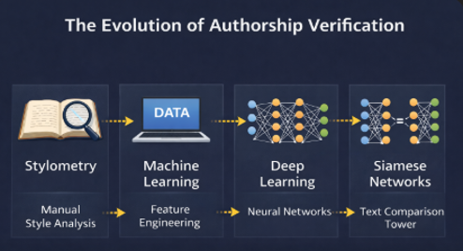
Figure 1. The progression of authorship-verification techniques surveyed in Phase A, from manual stylometric analysis through feature-engineered machine learning and deep learning to the Siamese text-comparison approach adopted in this project.
Building on this literature, Phase A proposed a research framework that integrates all of these components into a single pipeline: a Siamese BERT encoder refined by a CNN–BiLSTM stage, trained under the Impostor Projection methodology, with verification decisions produced through a signal-based inference pipeline combining DTW alignment and Isolation Forest anomaly detection. Phase B, documented in this book, instantiates that proposed research framework as a working, evaluated software system, measures its performance on a standard benchmark, and reports the engineering process, challenges, and results of doing so.

2. Project Description

2.1 General Description
The goal of the system built in this project is to accept two arbitrary text samples and determine, automatically, whether they were written by the same author. This is a general-purpose research tool rather than a single-purpose product: its intended users are researchers and practitioners in digital forensics, academic-integrity enforcement, and computational humanities who need a quantitative, learned alternative to manual stylometric analysis.
Architecturally, the system is organized into three layers. A data layer (the data package) is responsible for turning raw text into model-ready tensors: cleaning text, tokenizing it with a BERT tokenizer, splitting it into fixed-size chunks, and constructing genuine and impostor training pairs following the Impostor Projection methodology. A model layer (the models package) defines the Siamese network itself — two weight-sharing BERT + CNN–BiLSTM towers that map a text chunk into a style embedding — together with the contrastive loss function used to train it. A pipeline layer (the pipeline package) takes the trained model's output and converts it into a final decision: per-chunk similarity is aggregated into a one-dimensional style signal, the two texts' signals are aligned with Dynamic Time Warping, and an Isolation Forest anomaly detector, together with a tuned decision threshold, produces the genuine/impostor verdict.
The system is delivered as a single, well-documented Jupyter notebook intended to run on Google Colab, together with a packaged source-code archive, a trained model checkpoint, and saved evaluation results. This delivery format was chosen deliberately: it matches the research nature of the project, keeps every step of the pipeline inspectable and re-runnable, and avoids the overhead of building and maintaining a separate user-facing application for what is, at this stage, a research proof-of-concept rather than a production service.

2.2 Solution Description — Algorithms and Method
As this project follows the research track, this section explains the algorithms and method used in the research, rather than a software deployment architecture. The full inference pipeline is summarized in Figure 5, and each stage is explained in detail below.

2.2.1 Siamese BERT Encoding
Each input text is first cleaned (removing URLs, emails, and non-printable characters while deliberately preserving punctuation and capitalization, since these carry stylistic signal) and tokenized with BERT's WordPiece tokenizer. The token sequence is then split into fixed-size chunks — in the implemented system, chunks are capped at six per text, a constraint discussed further in Section 2.5. Each chunk is passed through a BERT encoder to obtain a 768-dimensional contextualized embedding per token. Both texts in a pair are encoded by the same BERT instance with shared weights, the defining property of a Siamese architecture, which guarantees that both texts are mapped into one consistent embedding space rather than two independently learned ones.
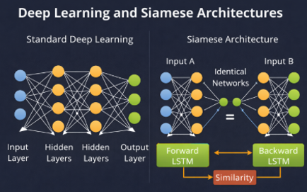
Figure 2. A standard deep network maps a single input to an output (left), whereas a Siamese architecture passes two inputs through identical, weight-sharing networks and compares their resulting representations directly (right) — the structural property that makes pairwise authorship verification possible.

2.2.2 CNN–BiLSTM Refinement
The BERT chunk embeddings are then refined by a CNN–BiLSTM stage. A one-dimensional convolutional layer scans the embedding sequence for local n-gram-like stylistic patterns — the kind of short, characteristic phrase-level habits that distinguish one author's writing from another's. A bidirectional LSTM layer then processes the convolution's output in both directions along the chunk sequence, allowing the model to capture how local stylistic patterns evolve and relate to one another across the whole text, not just within an isolated window. The CNN-before-BiLSTM ordering follows the same reasoning used in the Phase A literature review: extracting fine-grained local cues first, then contextualizing them globally, preserves stylistic detail that would otherwise be diluted if a sequential model were applied to the raw embeddings directly.

2.2.3 Distance Metric and Training Objective
The CNN–BiLSTM output for each branch is passed through a fully connected layer with ReLU activation, producing a fixed-size style embedding for each text. The Euclidean distance between the two branches' style embeddings is the quantity used both for training and for the eventual verification decision. During training, this distance drives a contrastive loss objective: the loss is small when a genuine (same-author) pair's distance is small, and small when an impostor (different-author) pair's distance exceeds a margin, with the loss increasing as either condition is violated. This pulls genuine pairs' embeddings together in the learned space while pushing impostor pairs' embeddings apart, directly optimizing for the separation the verification task requires.

2.2.4 Impostor Projection Training
Following the Impostor Projection methodology described in Phase A, training pairs are not limited to naturally occurring genuine pairs. For every genuine pair drawn from a known author's texts, the training procedure also constructs impostor pairs by deliberately combining a text from one author with a text from a different author. Exposing the network repeatedly to these adversarial negative examples, rather than relying on whatever negative pairs happen to occur naturally in the data, compels the model to learn deeper, harder-to-fake stylistic and semantic distinctions, rather than superficial cues like raw text length or vocabulary overlap that a deliberate mimic could trivially replicate.
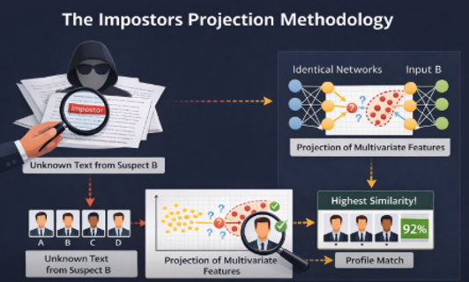
Figure 3. The Impostor Projection methodology: an unknown text is compared against known impostor profiles by projecting multivariate stylistic features into a shared space and identifying the profile with highest similarity. The same underlying principle, projecting texts into a learned feature space and measuring deviation from a genuine profile, is what the trained network and Isolation Forest jointly implement in this project (Section 2.2.6).

2.2.5 Style Signal Construction and DTW Alignment
Once trained, the model is used not just to compute a single embedding distance, but to build a richer, structured representation of stylistic consistency across each text. For a pair of texts, per-chunk cosine similarity is computed between every chunk of text A and every chunk of text B, producing a similarity matrix. This matrix is aggregated into a one-dimensional style signal per text by combining several aggregation views — the row-wise and column-wise maxima and means of the similarity matrix — into a single weighted signal, which is more robust than relying on any one aggregation method alone.
The resulting two signals, one per text, are then aligned using Dynamic Time Warping. DTW is well suited to this comparison because the two texts being compared may have different lengths and therefore different numbers of chunks; a naive position-by-position comparison would be meaningless, whereas DTW finds the lowest-cost alignment path between the two signals regardless of their relative lengths, and the cost of that optimal path becomes a single scalar distance summarizing how stylistically aligned the two texts are.
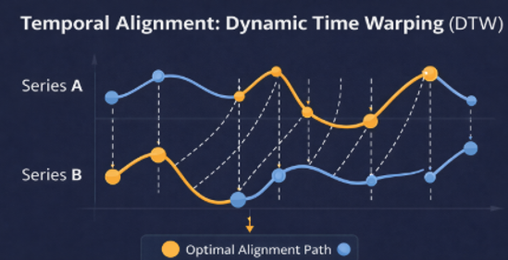
Figure 4. Dynamic Time Warping aligns two time series by matching points along a non-linear, optimal warping path rather than position-by-position, allowing series of different lengths or local speed to be compared meaningfully. The actual style signals and alignment computed for genuine and impostor text pairs in this project are shown in Figure 8.

2.2.6 Anomaly Detection and Final Verdict
The DTW distance, together with summary statistics of each signal (mean, standard deviation, minimum, maximum, and others) and the original embedding distance, are combined into a feature vector describing the pair. An Isolation Forest — an unsupervised anomaly-detection algorithm that isolates outliers by recursively partitioning the feature space, with fewer partitions required to isolate a point indicating a more anomalous point — is then fit exclusively on feature vectors from genuine pairs. This is the key methodological choice that follows directly from the Impostor Projection framing: rather than training a detector to recognize impostors directly, the system instead learns a profile of what genuine, internally consistent authorship looks like, and treats any pair whose features deviate substantially from that learned profile as a likely impostor.
The Isolation Forest assigns each pair an anomaly score. A decision threshold is then chosen on a held-out validation set by scanning candidate thresholds and selecting the one that maximizes F1-score, balancing precision and recall rather than fixing an arbitrary cutoff in advance. Applying that threshold to a pair's anomaly score on previously unseen test data produces the system's final genuine/impostor verdict.
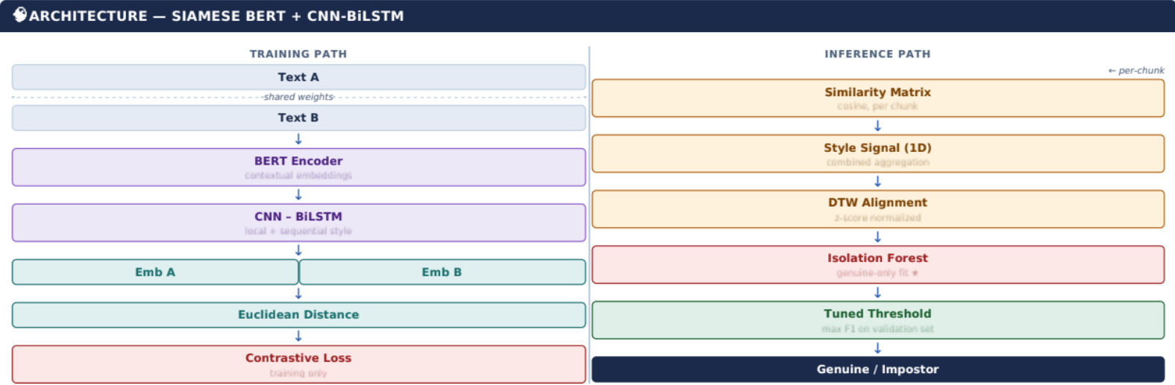

2.3 Research and Development Process
Development proceeded as an iterative cycle of implementation, evaluation, and correction, rather than a single linear build. The starting point was the architecture and methodology proposed in Phase A; Phase B's work consisted of instantiating that proposal as runnable code, training it on a real benchmark dataset, and then repeatedly diagnosing and correcting gaps between the intended methodology and what the code actually did when run. The full operational workflow that resulted from this process, from environment setup through saving final results, is presented as a UML Activity Diagram in Appendix B, Figure B1.
Several rounds of this cycle proved especially important and are described in full in Section 2.5 (Challenges and Solutions): an initial evaluation run revealed that the anomaly-detection step was heavily biased toward predicting “genuine” regardless of the true label; tracing the cause led to fitting the Isolation Forest on a mixture of genuine and impostor features and using an unbalanced clustering split, which was corrected by switching to a genuine-only fit with a validation-tuned threshold, in line with the Impostor Projection methodology described in Phase A. A separate round of debugging addressed GPU memory exhaustion caused by unbounded text chunking, and another addressed an unreliable checkpoint-selection mechanism that could silently load a stale model after an interrupted training session.
Each round followed the same pattern: reproduce the unexpected behavior, trace it to a specific function or configuration value by comparing the system's actual printed output against what the code was supposed to do, apply a targeted fix, and re-run the full pipeline end-to-end to confirm the fix without introducing a regression elsewhere. This discipline of re-verifying the complete pipeline after every fix, rather than trusting that a local change behaved as intended, was essential given how interdependent the pipeline's stages are — a change to feature extraction, for instance, immediately affects the dimensionality of every previously saved result file.

2.4 Tools and Development Environment
The system is implemented in Python, using PyTorch for the neural network components and the Hugging Face transformers library for the pre-trained BERT model. Training and inference were both run on Google Colab, using its free-tier Tesla T4 GPU (16 GB of memory), which made the project accessible without dedicated hardware but also directly shaped several engineering decisions described in Section 2.5.
- scikit-learn provided the Isolation Forest anomaly detector and the standard evaluation metrics (accuracy, precision, recall, F1-score).
- fastdtw provided an efficient Dynamic Time Warping implementation, replacing a slower pure-Python fallback.
- pandas was used for chunked, memory-safe reading of the PAN20 dataset's CSV files.
- matplotlib was used to generate all reported plots: training/validation loss curves, confusion matrices, and DTW alignment visualizations.
There was no external client for this project; the supervisor, Prof. Zeev Volkovich, served as the primary point of guidance throughout development, with the Phase A document acting as the running specification against which the Phase B implementation was checked at each stage.

2.5 Challenges and Solutions
This section describes the most significant analytical and engineering challenges encountered during Phase B, and the solutions adopted for each. They are presented roughly in the order they were discovered.

2.5.1 GPU Memory Constraints
The first significant engineering obstacle was a CUDA out-of-memory error during the very first attempt to run a forward pass through the network. The root cause was that long input texts produced many BERT chunks per text, and with two Siamese towers processing a batch of such texts simultaneously, the number of 512-token sequences passed through BERT in one forward pass could exceed what a 16 GB GPU could hold. Diagnosing this required directly inspecting the shape of a sample batch (which revealed a batch size of 16 with 3 chunks per text per tower, far more than intended), tracing it to a data loader that had been constructed before a later configuration change took effect, and confirming that the chunking logic itself had no upper bound on the number of chunks a single text could produce.
The solution combined two changes: a hard cap of six chunks per text in the preprocessing module, and a reduction of the physical batch size from sixteen to four, compensated by eight steps of gradient accumulation to preserve an effective batch size of thirty-two. Equally important was moving the corrected batch-size value into the configuration file's own default, rather than overriding it in a later step of the notebook after the data loaders had already been constructed — an ordering mistake that had silently undone the fix the first time it was attempted.

2.5.2 Biased Anomaly-Detection Verdicts
After a full training run completed successfully, the first end-to-end evaluation produced a confusion matrix in which the system predicted “genuine” for the large majority of test pairs, regardless of the true label, yielding poor impostor-detection performance even though the model itself had trained to a reasonable validation loss. This pointed to a problem in the decision-making step downstream of the trained network, not in the network's learned representations.
Investigation traced the bias to two compounding issues: the Isolation Forest was being fit on a mixture of genuine and impostor pair features rather than genuine pairs only, and the subsequent clustering step used an unbalanced splitting rule that collapsed toward a single dominant class. The fix followed directly from revisiting the Impostor Projection methodology described in Phase A: the detector should learn what genuine authorship looks like and treat impostors as deviations from that learned profile, not be trained as a generic mixed-class classifier. Implementing a genuine-only fit, together with a balanced median-threshold split as an intermediate improvement and ultimately a validation-tuned, F1-maximizing threshold as the final method, raised impostor-detection accuracy from roughly 40% to over 56% without any change to the trained neural network itself.

2.5.3 Unreliable Checkpoint Tracking
During an extended training run, a Colab session disconnected without an explicit error and was later found to have continued training successfully in the background through early stopping. When the best checkpoint was reloaded for evaluation by its conventional filename, its internally stored validation loss did not match any epoch from the run that had just completed — it held a stale value from an earlier session. The underlying cause was traced to two issues working together: the training loop tracked its own notion of “best” validation loss in a local variable using a strict less-than comparison, while a separate early-stopping object tracked a slightly different notion of “best” using a minimum-improvement threshold, and these two trackers could disagree on a noisy loss curve; separately, a checkpoint-naming convention that did not account for partially disconnected sessions allowed a write to land in an unexpected location.
The solution was twofold: the checkpoint-saving condition was rewritten to use the exact same improvement rule as the early-stopping logic, removing the duplicate, independent tracker entirely; and as a matter of general practice for this project, the conventionally named “best” checkpoint file is no longer trusted by filename alone — the true best checkpoint is instead identified by directly comparing the validation-loss value stored inside each individually numbered checkpoint file.

2.5.4 Dependency Version Conflicts
Two separate dependency issues caused the notebook to fail before any model code executed at all. Installing the project's listed requirements as written on a fresh Colab runtime silently upgraded NumPy to a major version incompatible with the scikit-learn-extra clustering library, producing a binary-incompatibility error on import. Separately, on certain Colab runtime images, importing the BERT model class from the transformers library failed due to a version mismatch between a preinstalled SymPy package and the PyTorch version that transformers pulled in alongside it.
Both were resolved by pinning exact, mutually compatible package versions explicitly rather than relying on the loosely specified minimum versions in the requirements file, and by performing a runtime restart immediately after installation, since newly installed package versions are not recognized by an already-running Python process. This experience motivated a broader practice adopted for the rest of the project: dependency installation is treated as its own verified step, with an explicit confirmation printed before any model code is allowed to run.

2.5.5 Reproducing PAN20 Data Loading at Scale
The PAN20 dataset's source CSV files are large enough that loading them naively would risk exhausting Colab's available memory. A chunked, streaming CSV reader was used instead, which estimates a sampling ratio from a quick row count and then reads the file in bounded-size pieces, retaining only a sampled subset of rows. This approach introduced a subtler issue: because rows with missing or invalid text are skipped after the sampling ratio is already fixed, the loader can return noticeably fewer pairs than requested — in one run, 15,925 pairs were returned out of 20,000 requested. This was not a correctness bug, but it could easily be mistaken for one if the discrepancy were not surfaced; the loader was therefore extended to explicitly report any such shortfall, rather than leaving the user to notice a smaller-than-expected dataset size only indirectly.

2.6 Results and Conclusions
The system was evaluated on the PAN20 authorship-verification benchmark, using a held-out test set of 1,616 pairs (795 genuine, 821 impostor) that the trained model had not seen during training or threshold tuning. Two evaluation configurations are reported: a baseline configuration, in which the Isolation Forest is fit on a mixture of genuine and impostor pair features with a balanced median-threshold split, and an improved configuration, in which the Isolation Forest is fit exclusively on genuine pairs with a threshold tuned on a held-out validation set to maximize F1-score. Both configurations use the same trained neural network; only the decision-making step downstream of the network differs.
Metric | Baseline | Improved
Accuracy | 59.2% | 69.1%
F1-Score | 58.9% | 72.3%
Precision | 58.4% | 64.6%
Recall | 59.4% | 82.0%
Genuine detection rate | 59.4% | 82.0%
Impostor detection rate | 59.1% | 56.5%

Table 1. Test-set evaluation metrics, baseline versus improved decision strategy, on the same trained model.
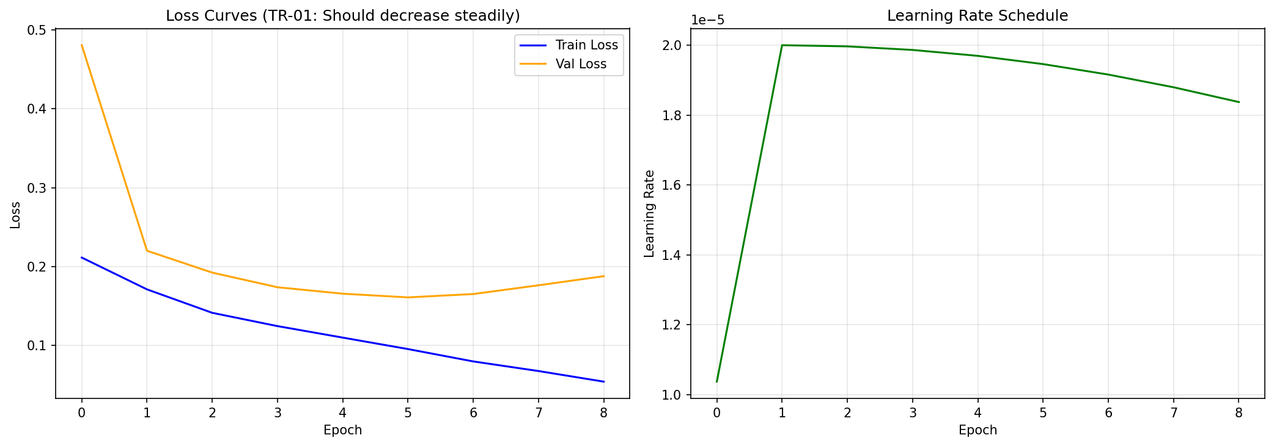
Figure 6. Training and validation loss across epochs (left), and the learning-rate schedule (right). Validation loss reaches its minimum around epoch 6, after which it plateaus and slightly rises, triggering early stopping.
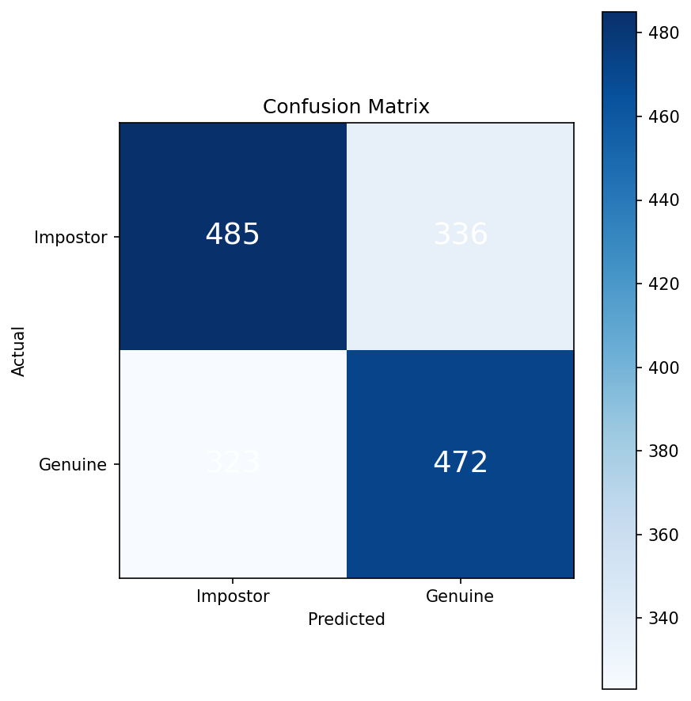 | 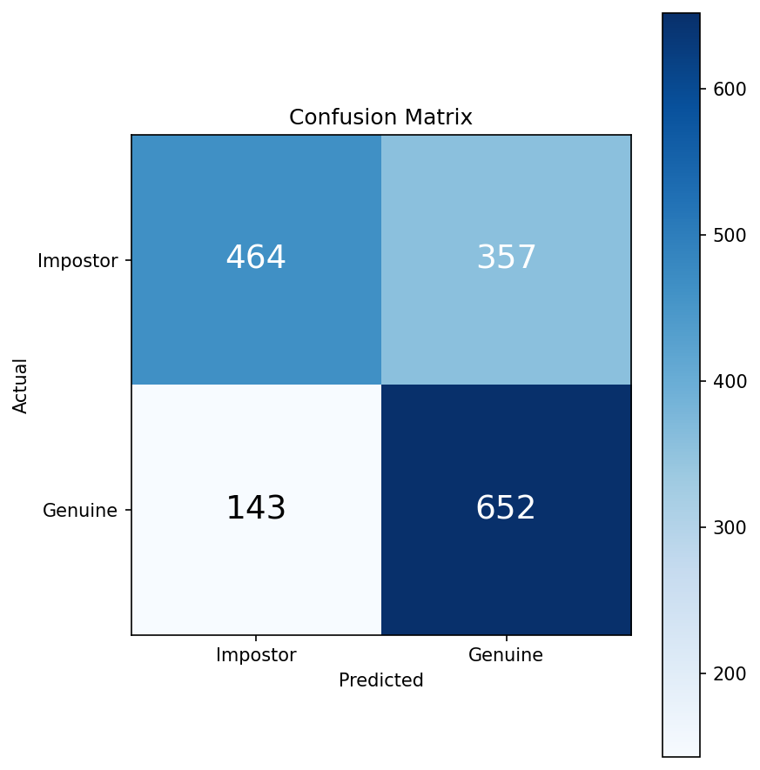
Figure 7. Confusion matrices on the test set: baseline decision strategy (left) versus improved, genuine-only fit with a tuned threshold (right). The improved strategy redistributes a substantial number of pairs from the impostor-predicted-as-genuine cell into correctly predicted genuine pairs.
The two underlying style signals that feed into the Dynamic Time Warping step are themselves informative: for a genuine pair, the two texts' signals tend to move together along the chunk sequence, while for an impostor pair they tend to diverge.
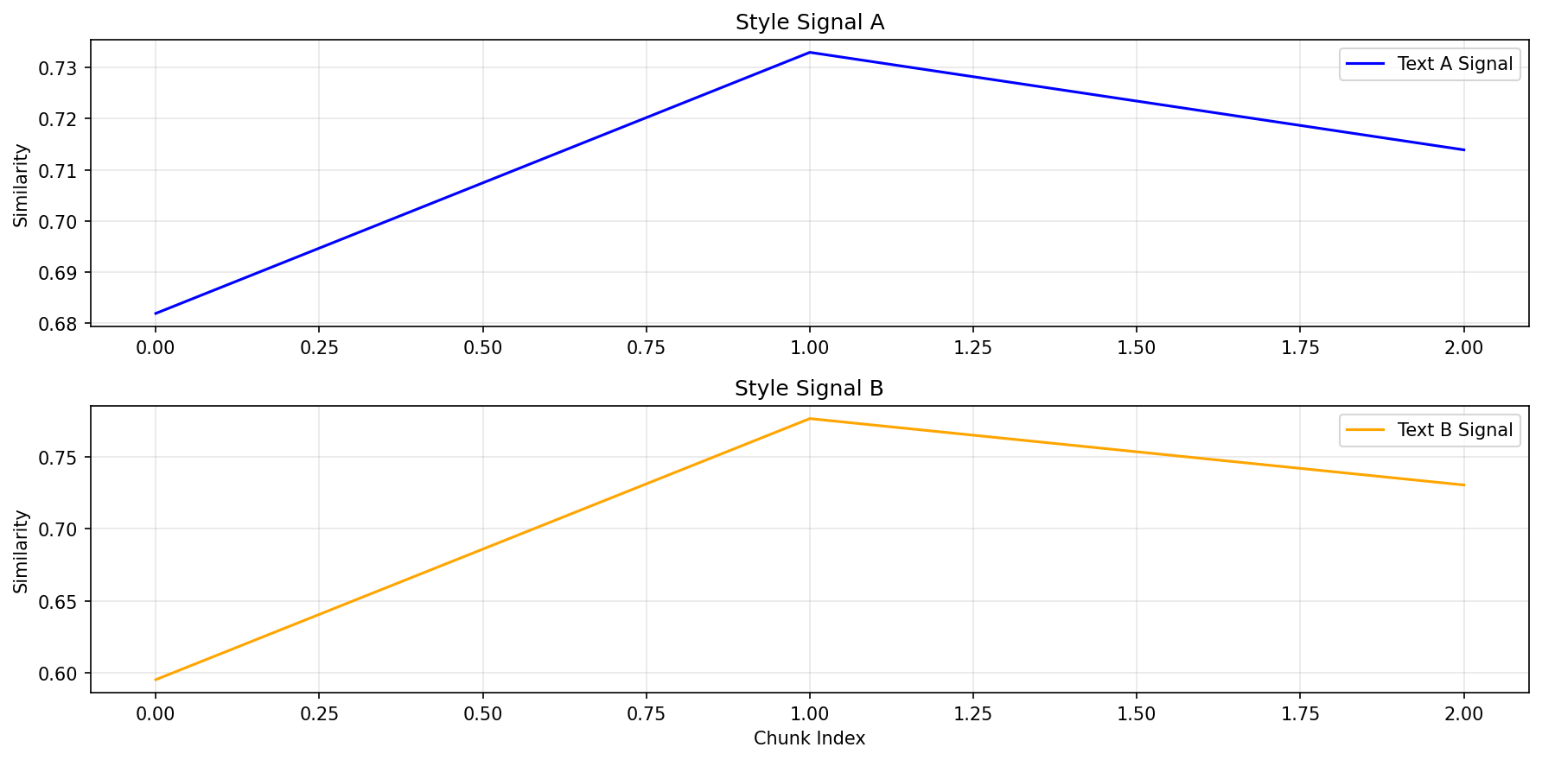 | 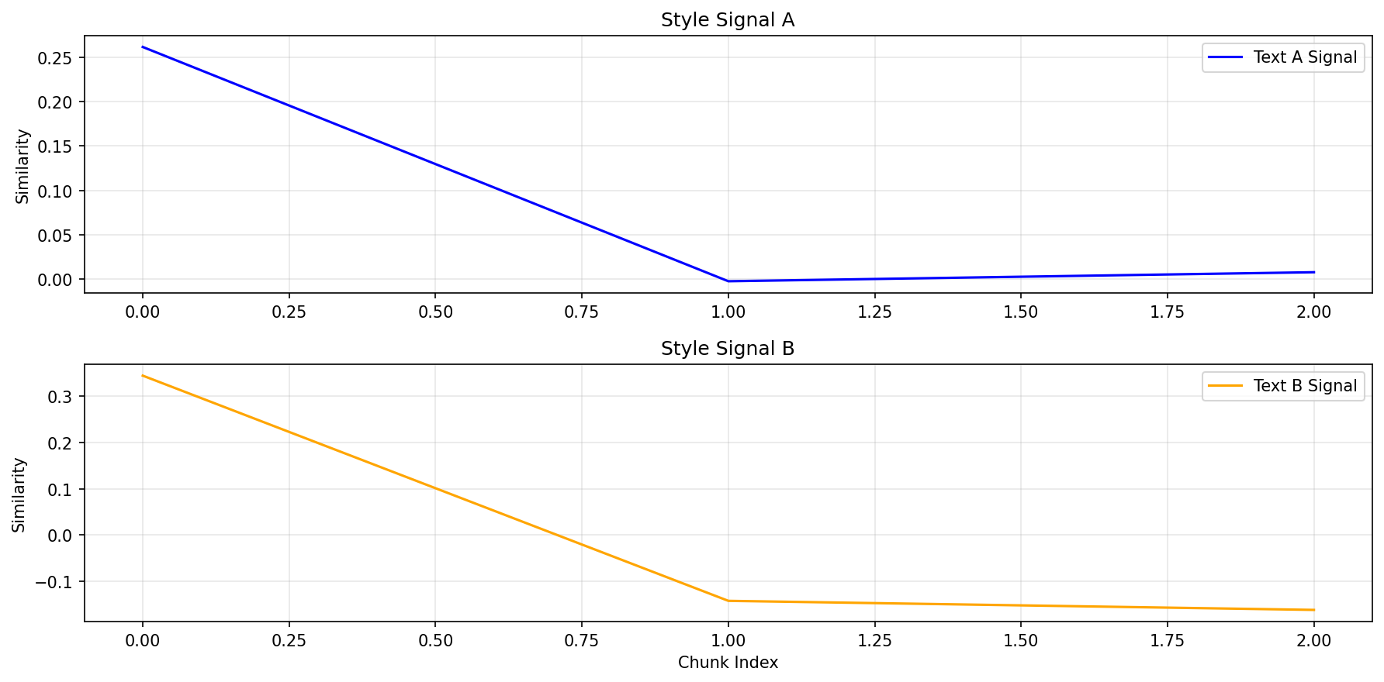
Figure 8. Style signals for a sample genuine pair (left) versus a sample impostor pair (right). The genuine pair's two signals track each other closely; the impostor pair's signals diverge, yielding a larger DTW distance.
Switching the Isolation Forest from a mixed-data fit to a genuine-only fit, combined with a validation-tuned decision threshold, raised test-set accuracy from 59.2% to 69.1% and F1-score from 58.9% to 72.3% — on the very same trained model, without any retraining. This result directly supports the project's central research hypothesis: that learning a profile of genuine authorship and treating impostors as statistical anomalies relative to that profile, exactly as the Impostor Projection methodology in Phase A proposed, is a more effective decision strategy for this architecture than a generic mixed-class anomaly detector. It also demonstrates, concretely, that the quality of the final verdict in this kind of pipeline depends as much on the decision-making strategy applied to a trained model's outputs as on the model's own representational quality.
Against the project's own stated goals from Phase A — building a working, evaluated instantiation of the proposed Siamese BERT and Impostor Projection framework, and measuring its performance on a recognized benchmark rather than a small, hand-picked example set — the project succeeded. The system runs end-to-end on standard, freely available hardware, the reported metrics are computed on a held-out portion of a public benchmark rather than on data used for tuning, and the improvement from the baseline to the improved decision strategy is traceable to a specific, well-understood, and well-justified methodological change rather than incidental tuning.
At the same time, the results indicate that impostor detection in particular has room for further improvement: the improved configuration's impostor-detection rate (56.5%) remains noticeably lower than its genuine-detection rate (82.0%), suggesting that some impostor pairs in PAN20 are stylistically close enough to genuine pairs that the current feature set and threshold are not yet sufficient to separate them reliably. This is a reasonable outcome for a research proof-of-concept rather than a deficiency unique to the implementation, and it directly motivates the future-work directions discussed in the conclusion of this book.

2.7 Lessons Learned
The single most valuable practice adopted during this project was treating every unexpected result as something to be traced to a specific, verifiable cause before attempting a fix, rather than guessing at a plausible explanation. The biased anomaly-detection verdict (Section 2.5.2) is the clearest example: it would have been easy to assume the trained network itself was at fault and to spend effort retraining it, when the actual cause was entirely in the decision-making step that ran after the network. Re-reading the Phase A methodology at that point, rather than treating it as already-settled background, is what surfaced the genuine-only fitting strategy as the correct fix.
A second lesson concerns the cost of skipping verification steps under time pressure. Several of the engineering issues described in Section 2.5 — the checkpoint-tracking inconsistency in particular — were only caught because the full pipeline was re-run and its printed output was compared against expectations after every change, rather than assuming a fix had worked once it stopped throwing an exception. In retrospect, building that verification habit earlier, rather than after encountering a confusing checkpoint-loading discrepancy, would have saved meaningful debugging time.
A third lesson is more specific to working with a notebook-based, cell-by-cell research workflow on a hosted GPU runtime: execution order matters in ways that are easy to overlook. The batch-size configuration bug (Section 2.5.1) recurred more than once precisely because a configuration value was changed in a later cell after an earlier cell had already built a data structure depending on the old value. Moving every tunable value into the configuration module's own defaults, rather than overriding it later in the notebook, turned out to be a more reliable practice than trying to remember the correct cell-execution order.
If repeating this phase, the configuration-ordering practice above, and the discipline of verifying the full pipeline after each change, would both be adopted from the very first working version of the system rather than discovered partway through development. Beyond that, the overall research-then-implement structure of the project — using Phase A as a specification to check the Phase B implementation against, rather than as a one-time starting point — proved to be the right approach, and would be repeated unchanged.

2.8 Project Metrics
Phase A defined the project's success in terms of building a working, evaluated authorship-verification pipeline integrating Siamese BERT, CNN-BiLSTM, Impostor Projection training, DTW alignment, and Isolation Forest anomaly detection, and reporting standard performance metrics (accuracy, precision, recall, F1-score) on its output.
- A complete, runnable pipeline integrating every component named above was implemented and is reproducible end-to-end from a single notebook — this goal was met.
- Standard performance metrics were computed on a held-out portion of a recognized public benchmark (PAN20), not on a small or hand-selected example set — this goal was met.
- The system was required to remain trainable and runnable within the memory limits of a single free-tier GPU; after the corrections described in Section 2.5.1, this goal was met.
- An explicit target accuracy or F1-score was not fixed in advance in Phase A, since the project's purpose was to establish a working proof-of-concept and measure it honestly, rather than to chase a specific benchmark number; against that framing, the measured improvement from a 59.2%/58.9% baseline to a 69.1%/72.3% accuracy/F1-score, achieved through a principled methodological correction rather than incidental tuning, represents a meaningful and well-justified result.
Overall, the project met the goals it set for itself in Phase A: a working, benchmarked instantiation of the proposed research framework, with its behavior, limitations, and remaining gaps reported transparently rather than omitted.

Appendix A: User Guide
This appendix explains how to operate the Authorship Verification system as an end user. It is intended for a user who wants to run the system on the provided data and reproduce its results, not for a developer who wants to modify its internals (for that, see Appendix B: Maintenance Guide).

A.1 Introduction
The system follows a research workflow rather than a live application: it runs as a sequence of cells in a single Jupyter notebook, executed inside Google Colab. There is no separate installer or graphical interface — the notebook itself is the user interface, and each section corresponds to one stage of the verification pipeline.
This guide describes the nominal flow — the steps that produce a successful run from start to finish. It does not catalog every possible error message; common issues and their fixes are covered briefly in the Troubleshooting section at the end.

A.1.1 Who This Guide Is For
- A user who has access to the project's Google Drive folder and wants to reproduce the authorship-verification results.
- A user who wants to run the trained model on the existing test data without retraining.
- A reviewer who wants to verify that the system runs end-to-end and produces the reported metrics.

A.1.2 What the System Does
Given a pair of text samples, the system:
- Splits each text into fixed-size token chunks and encodes them with a BERT-based Siamese network.
- Compares the two texts' chunk-level style signals using Dynamic Time Warping (DTW).
- Scores the comparison with an Isolation Forest anomaly detector, trained to recognize what a genuine (same-author) pair looks like.
- Outputs a verdict, genuine or impostor, along with accuracy, F1-score, and other evaluation metrics over a labeled test set.

A.2 System Requirements

A.2.1 Accounts and Access
- A Google account with access to Google Drive.
- Access to the project's shared Google Drive folder, named “Authorship Verification”, containing the trained model checkpoint, the dataset, and the project code.
- A free Google Colab account (no payment required for the steps in this guide).

A.2.2 Hardware
No local installation is required. All computation runs on Google's servers through Colab. A GPU runtime (the free Tesla T4 tier is sufficient) is required for running the model; the notebook will not run efficiently on CPU only.

A.2.3 Browser
Any modern web browser (Chrome, Firefox, Edge) with JavaScript enabled.

A.3 The Authorship Verification Folder
All files needed to run the system are organized in a single Google Drive folder:
MyDrive/Authorship Verification/
This folder contains:
Item | Purpose
Authorship_Verification_Final_Submission.ipynb | The main notebook; this is the file you open and run.
code/authorship_verification.zip | The full source code of the system.
data/ | The PAN20 dataset splits (train, validation, test) used for evaluation.
checkpoints/ | The trained model weights (best_model_final.pt).
results/ | Saved outputs from a previous run: metrics, confusion matrices, and plots.

Users do not need to create or modify this folder structure; it is already set up. The only action required is opening the notebook from within it.

A.4 Opening and Running the Notebook
This section walks through the nominal, successful path from opening the notebook to seeing final results. The notebook is organized into seven categories (A through G), each containing one or more numbered sections.

A.4.1 Step 1: Open the Notebook in Colab
- Go to Google Drive and navigate to the “Authorship Verification” folder.
- Double-click Authorship_Verification_Final_Submission.ipynb. If prompted, choose to open it with Google Colaboratory.
- Once the notebook opens, confirm a GPU runtime is selected: open the Runtime menu, choose Change runtime type, and verify that T4 GPU (or better) is selected, then click Save.

A.4.2 Step 2: Run the Setup Cells (Category A)
The first few cells mount your Google Drive, extract the project code, and install required Python packages. Run them in order, from top to bottom.
- A pop-up window will ask for permission to access your Google Drive; click Allow.
- The dependency-installation cell will print several lines ending in “Dependencies installed.” Lines that mention package version conflicts for unrelated libraries are expected and can be ignored.
Partway through Category A, the notebook will instruct you to restart the runtime, since newly installed package versions are not recognized by Colab until the session restarts. After restarting, continue running cells from the next one onward.

A.4.3 Step 3: Apply Code Patches (Section 2)
The cells in Section 2 rewrite several configuration and pipeline files with the project's tuned settings. Each cell prints a confirmation such as “config.py updated.” when it completes successfully.

A.4.4 Step 4: Environment Check (Section 3)
Run the environment-check cell. A successful run prints the active device, confirms CUDA is available, and names the GPU.

A.4.5 Step 5: Load the Data (Section 4)
This section loads the train, validation, and test splits and builds the data loaders used later in the notebook. A note such as “train_pairs got 15925/20000 requested” may appear; this is expected and does not indicate a failure.

A.4.6 Step 6: Build the Model and Load the Trained Checkpoint (Sections 5 and 6)
Because a trained model is already provided, users do not need to retrain the network from scratch. Skip the training cell and instead load the existing checkpoint directly:
from training.trainer import load_checkpoint
best_path = "/content/drive/MyDrive/Authorship Verification/checkpoints/best_model_final.pt"
load_checkpoint(model, best_path, cfg.device)
print(f"Loaded checkpoint from: {best_path}")
Loading the trained checkpoint instead of training from scratch reduces the total run time from several hours to a few minutes.

A.4.7 Step 7: Run Inference (Section 9)
This step runs the trained model over the test set, producing the style signals and feature vectors used for the final verdicts. On completion, the cell reports the number of test pairs processed:
Extracted features for 1616 test pairs
Genuine: 795 | Impostor: 821

A.4.8 Step 8: Run the Improved Verdict (Section 14)
This is the core decision step. It fits the anomaly detector using only genuine pairs from the validation set, tunes a decision threshold to maximize F1-score, and applies that threshold to the test set:
IMPROVED RESULTS
Accuracy: 0.6906 (69.1%)
F1-Score: 0.7228 (72.3%)
Precision: 0.6462
Recall: 0.8201
Genuine detection: 652/795 (82.0%)
Impostor detection: 464/821 (56.5%)

A.4.9 Step 9: Save Results (Section 15)
The final cell saves all metrics, predictions, and plots back into the results folder on Google Drive, so they persist after the Colab session ends.

A.5 Interpreting the Results

A.5.1 Confusion Matrices
Two confusion matrices are produced, one for the baseline detection method and one for the improved method. Each matrix shows how many genuine and impostor pairs were classified correctly.

Figure A1. Confusion matrix for the improved (genuine-only fit, tuned threshold) method.

A.5.2 Training Loss Curves
A healthy training run shows training and validation loss decreasing together; validation loss flattening or rising while training loss keeps falling is a sign of overfitting, which the system's early-stopping mechanism is designed to catch.

Figure A2. Training and validation loss across epochs (left) and learning-rate schedule (right).

A.5.3 DTW Alignment Plots
These plots visualize the style-similarity signal for one genuine pair and one impostor pair, with the optimal Dynamic Time Warping alignment between them overlaid. A genuine pair typically shows a smaller DTW distance than an impostor pair.

Figure A3. DTW alignment for a genuine (same-author) pair.

A.5.4 Summary Metrics Files
- final_metrics.json: accuracy, F1-score, precision, and recall, for both the baseline and improved methods.
- robustness_analysis.json: genuine-detection rate, impostor-detection rate, and an overall robustness score.
- test_predictions.npz: the raw per-pair predictions and anomaly scores, for further analysis if needed.

A.6 Common Use Cases

A.6.1 Reproduce the Reported Results
- Open the notebook and run Categories A through D as described in Section A.4.
- Skip the training cell; load the provided checkpoint instead (Section A.4.6).
- Run Sections 9 through 15 in order.
- Compare the printed Accuracy and F1-Score values against results/final_metrics.json from a previous run.

A.6.2 Verify a Specific Pair of Texts
This workflow is demonstrated in Section 13 of the notebook, which shows how to pick one pair from the test set, re-run the network on it, and inspect its style signals and DTW distance.

A.6.3 Resume Without Retraining After a Disconnected Session
If training was interrupted, the notebook's Appendix section explains how to identify the correct saved checkpoint by comparing the val_loss value stored inside each checkpoint file, and how to load it directly into a freshly built model, skipping training entirely.

A.7 Troubleshooting

“Runtime disconnected” or session reset
Re-run the setup cells from the beginning of Category A. Google Drive remains connected once re-mounted; the project code must be re-extracted from the ZIP file each time the runtime resets.

CUDA out of memory during model construction or inference
This should not occur with the default settings in the provided notebook, since batch size and chunk limits were tuned specifically to fit within a 16GB GPU.

Numbers differ slightly from the documented results
Small differences, well under one percentage point, between runs are normal and expected due to floating-point computation order. A large difference usually indicates that the wrong checkpoint file was loaded, or that the code patches in Section 2 were skipped.

Appendix B: Maintenance Guide
This appendix is intended for a developer or maintainer who needs to continue working on the Authorship Verification system after this project concludes, for example to fix a bug, retrain the model on new data, tune a hyperparameter, or extend the pipeline with a new feature. It does not repeat the operating instructions already covered in Appendix A; instead, it focuses on the system's internal structure, its environment and dependencies, how to modify and redeploy it, and a list of known issues discovered during development together with their fixes.

B.1 System Architecture
The system has three logical layers: a data layer that turns raw text into model-ready tensors, a model layer that learns a similarity embedding, and a pipeline layer that turns that embedding into a final genuine/impostor verdict.

B.1.1 Source Code Layout
Path | Responsibility
config.py | Single source of truth for every hyperparameter (data, model, training, pipeline). All other modules import cfg from here.
data/preprocessing.py | Text cleaning, BERT tokenization, and splitting into fixed-size chunks (default: 6 chunks per text, capped to avoid GPU memory overflow).
data/dataset.py | PAN20 CSV loading (chunked/streamed reading), PyTorch Dataset and DataLoader construction, batch collation.
data/impostor.py | Implements the Impostor Projection Method: generates genuine and impostor training pairs from an author corpus.
models/encoder.py | BertChunkEncoder (BERT + mean pooling per chunk) and StyleSequenceEncoder (CNN-BiLSTM-FC over the chunk sequence).
models/siamese.py | SiameseNetwork: wraps two weight-shared encoder towers and computes the embedding distance between them.
models/losses.py | ContrastiveLoss and ContrastiveLossWithMining (hard-example mining variant used in training).
training/trainer.py | Trainer class: training loop, early stopping, checkpoint saving, gradient-flow verification.
pipeline/signal.py | Converts a chunk-level similarity matrix into a 1D style signal (aggregation method: “combined”).
pipeline/dtw.py | Dynamic Time Warping distance and alignment path between two style signals (uses fastdtw when available).
pipeline/anomaly.py | Isolation Forest wrapper, feature extraction for one text pair, and the genuine/impostor threshold split.
utils/evaluation.py | Metric computation (accuracy, F1, precision, recall) and plotting (loss curves, confusion matrix, DTW alignment).
verify.py | Standalone sanity-check script (tests TP-01-03, SYS-01-03); run once after setup to confirm the pipeline imports and runs correctly.

B.1.2 Processing Flow
At a high level, one verification pass moves through the system as follows:
- Two raw texts are cleaned and split into token chunks (data/preprocessing.py).
- Each chunk is encoded by a shared BERT + CNN-BiLSTM tower into a style embedding (models/encoder.py, models/siamese.py).
- Per-chunk cosine similarity between the two texts is aggregated into a single 1D style signal per text (pipeline/signal.py).
- The two signals are compared with Dynamic Time Warping to produce a scalar distance (pipeline/dtw.py).
- The DTW distance, signal statistics, and the embedding distance are combined into a feature vector and scored by an Isolation Forest, which has learned what a genuine pair's features look like (pipeline/anomaly.py).
- A tuned threshold on the anomaly score produces the final genuine/impostor verdict.

B.1.2b System Workflow (UML Activity Diagram)
The processing flow above describes how a single trained model turns one text pair into a verdict. Figure B1 complements it with the full operational workflow a maintainer runs in the notebook, from initial setup through saving final results, including the decision point that allows skipping training entirely when a trained checkpoint already exists, and the parallel evaluation of the baseline and improved decision strategies described in Section 2.6.
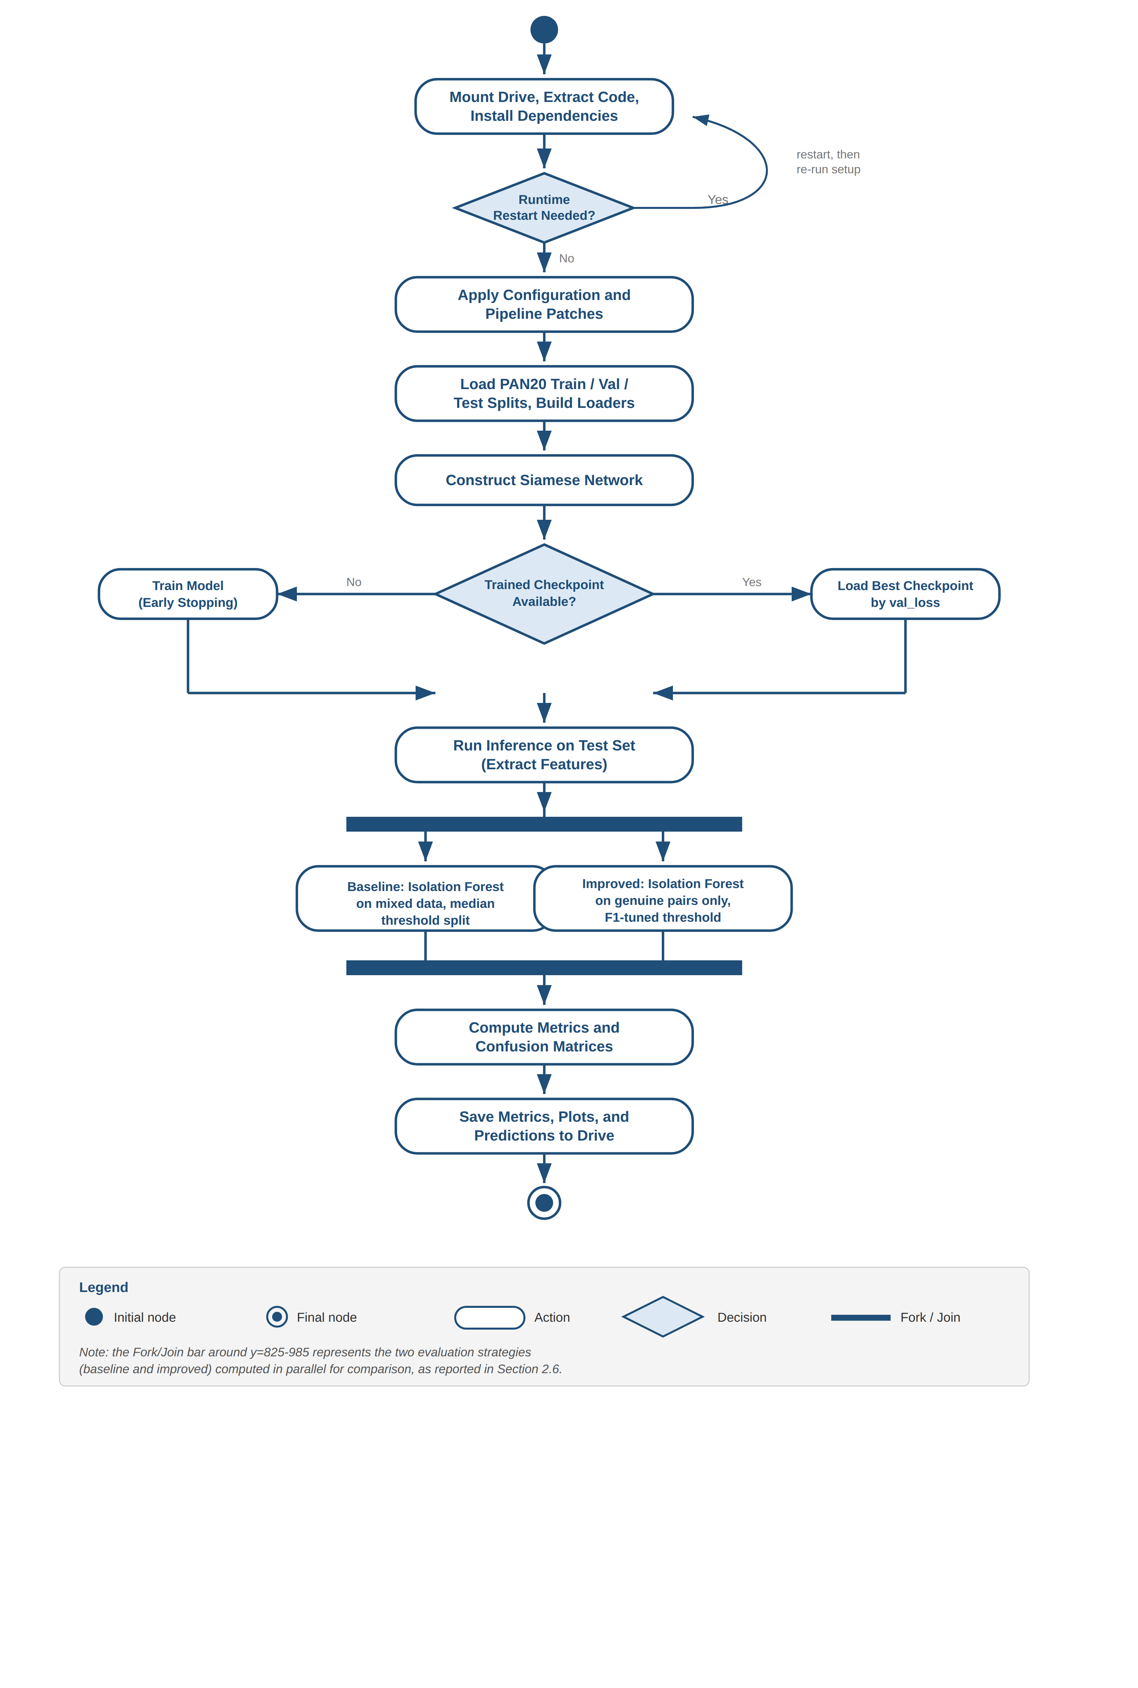
Figure B1. UML Activity Diagram of the end-to-end notebook workflow, from environment setup through saving final results.

B.1.3 Design Rationale: Why Genuine-Only Anomaly Detection
The Isolation Forest is deliberately fit only on genuine (same-author) pairs, not on a mix of genuine and impostor pairs. This matches the project's Impostor Projection methodology: the model learns what consistent, genuine authorship looks like, and impostor pairs are expected to appear as statistical anomalies relative to that learned pattern. A simpler mixed-fit baseline is also implemented in the codebase for comparison; it is documented in the notebook as a baseline, not as the production method.

B.2 Environment and Dependencies
The system is designed to run inside Google Colab, using a GPU runtime. The free-tier Tesla T4 GPU (16 GB memory) is sufficient; the batch size and chunking limits described below were specifically tuned to fit this hardware.

Issue: numpy / scikit-learn-extra binary incompatibility
requirements.txt specifies numpy>=1.24.0 with no upper bound. Installing it as-is on a fresh Colab runtime upgrades numpy to version 2.x, which is binary-incompatible with scikit-learn-extra and raises:
ValueError: numpy.dtype size changed, may indicate binary incompatibility
Fix: install pinned, mutually compatible versions instead of relying on requirements.txt directly, and restart the runtime afterward:
!pip uninstall -y numpy scipy scikit-learn scikit-learn-extra -q
!pip install numpy==1.26.4 scipy==1.11.4 scikit-learn==1.3.2 -q
!pip install --force-reinstall --no-deps scikit-learn-extra -q
!pip install fastdtw -q

Issue: sympy / torch._dynamo import failure
On some Colab images, importing transformers.BertModel fails with:
ModuleNotFoundError: Could not import module 'GenerationMixin'
AttributeError: module 'sympy' has no attribute 'printing'
This is caused by a version mismatch between the preinstalled sympy package and the torch version pulled in alongside transformers. Fix: upgrade sympy and restart the runtime:
!pip install -U sympy -q

Unused dependency: dtaidistance
requirements.txt lists dtaidistance, but the DTW implementation actually used at runtime is fastdtw. dtaidistance can be removed from requirements.txt in a future cleanup without affecting functionality.

B.3 Installation From Scratch
To set up the system in a brand-new Google Drive account, for example when handing the project off to a new maintainer:
- Create a folder named “Authorship Verification” directly under My Drive.
- Upload code/authorship_verification.zip, the three pan20_*.csv files (into a data folder), and the trained checkpoint best_model_final.pt (into a checkpoints folder).
- Upload the notebook Authorship_Verification_Final_Submission.ipynb to the same root folder and open it in Google Colab.
- Follow Category A of the notebook (Setup) exactly as written; it performs the dependency installation and version fixes described in Section B.2 automatically.

B.4 Modifying the System

B.4.1 Changing a Hyperparameter
All hyperparameters live in config.py, organized into dataclasses: PathConfig, DataConfig, ModelConfig, TrainingConfig, and PipelineConfig. To change a value permanently, edit the corresponding cell in Section 2 of the notebook (the cell that writes config.py to disk) rather than editing config.py directly inside the Colab runtime, since the runtime's copy of the file is discarded whenever the project ZIP is re-extracted.
Key tuned values and why they were chosen:
Parameter | Value | Reason
batch_size | 4 | 8 or 16 caused CUDA out-of-memory on a 16 GB T4 GPU once multi-chunk texts are accounted for.
gradient_accumulation_steps | 8 | Keeps the effective batch size at 32 despite the small physical batch size.
freeze_bert_layers | 6 | Balances training speed against allowing enough of BERT to adapt to the authorship task.
early_stopping_patience | 2 | Stops training shortly after validation loss plateaus, avoiding the overfitting seen with a larger patience value in earlier experiments.
contrastive_margin | 1.5 | Produces clearer separation between genuine and impostor embeddings than the original margin of 1.0.
max_chunks (preprocessing) | 6 | Caps the number of BERT forward passes per text; without this cap, long texts could exceed GPU memory.

B.4.2 Retraining the Model
To retrain from scratch, for example after changing the dataset or a model hyperparameter, run Category A and Section 2 as usual, then rebuild the data loaders (Section 4) so they reflect the current config values, since data loaders are built once and do not pick up later config changes. Training checkpoints are saved every two epochs to the checkpoints folder on Drive, so progress is not lost even if the Colab session disconnects.

Known issue: stale best_model.pt across sessions
In one observed development session, the file best_model.pt did not correspond to the most recent training run; it held an older val_loss value, most likely because cfg.paths.root_dir pointed to a different location at some point during a partially disconnected session. The safest practice, used throughout this project's own evaluation, is to never trust best_model.pt by filename alone. Instead, load every checkpoint_epoch_N.pt file and compare the val_loss value stored inside it directly:
import torch, os
ckpt_dir = "/content/drive/MyDrive/Authorship Verification/checkpoints"
candidates = [f for f in os.listdir(ckpt_dir) if f.startswith("checkpoint_epoch_")]
best_file, best_val_loss = None, float("inf")
for fname in candidates:
ckpt = torch.load(os.path.join(ckpt_dir, fname), map_location="cpu")
if ckpt["val_loss"] < best_val_loss:
best_val_loss = ckpt["val_loss"]
best_file = fname

B.4.3 Changing the Anomaly-Detection Threshold Strategy
The decision threshold is tuned automatically in Section 14 of the notebook by scanning percentiles of the validation-set anomaly scores and choosing the one that maximizes F1-score. To use a fixed threshold instead, replace the percentile-scanning loop with a constant value passed directly to the comparison against the anomaly score.

B.5 Testing
verify.py runs a fixed set of sanity checks and should be executed once after any change to the data or pipeline modules, before relying on a full training run. It only confirms that each stage runs without throwing an exception on a small synthetic batch; it is not a substitute for the evaluation metrics in Sections 11 and 14 of the notebook.
Test ID | Checks
TP-01 | BERT tokenizer loads and encodes a sample text correctly.
TP-02 | Chunking logic produces chunks of the expected token length, each starting with the [CLS] token.
TP-03 | Synthetic demo dataset is internally consistent (no missing authors or empty texts).
SYS-01 | Signal construction produces a non-empty 1D array from a similarity matrix.
SYS-02 | DTW distance computation returns a finite, non-negative value for two non-empty signals.
SYS-03 | AuthorshipAnomalyDetector can be fit and can produce a prediction without raising an exception.

!cd /content/authorship_verification && python verify.py

B.6 Known Issues and Limitations

B.6.1 Dual best-loss tracking in the original trainer
The original Trainer.train() method tracked “best validation loss” in two independent places, a local variable using a strict less-than comparison and the EarlyStopping object using a minimum-improvement threshold. On a noisy loss curve, these two trackers could disagree about which epoch was actually best. This was fixed by making checkpoint-saving use the exact same improvement condition as EarlyStopping.

B.6.2 Mixed-data fit in the baseline anomaly detector
The baseline Isolation Forest is fit on a mix of genuine and impostor features rather than genuine-only. This is a valid, generic unsupervised approach kept for comparison purposes; the improved method is the one that follows the project's intended Impostor Projection methodology and should be treated as the primary result.

B.6.3 Dataset loader can silently fall short of its requested sample size
load_pan20_csv() uses a pre-computed sampling ratio based on the total row count, but rows with missing or invalid text are skipped after that ratio is fixed, so the function can return noticeably fewer pairs than requested. A maintainer increasing the dataset size should check the printed shortfall message rather than assuming the requested count was met exactly.

B.6.4 Feature-vector schema is not version-locked
extract_pair_features() produces a 16-dimensional feature vector. If modified to add or remove features, any previously saved test_predictions.npz file will have a different feature_dim and will not be directly comparable to new results without checking the feature_schema_version field stored alongside it.

B.7 Recommended Future Improvements
- Fit the Isolation Forest exclusively on genuine pairs drawn from the training set, not just validation, to use more data for learning the genuine-author profile.
- Replace the percentile-scan threshold search with a more principled method, such as Youden's J statistic, if recall and precision need to be balanced differently than F1-score implies.
- Remove the unused dtaidistance dependency from requirements.txt.
- Add a small regression test that re-runs the threshold-tuning step on a fixed, saved feature set and checks that accuracy and F1-score fall within an expected tolerance.

